|  |
| --- |
| **Exercise 1: Control Structures**  **Scenario 1:** The bank wants to apply a discount to loan interest rates for customers above 60 years old.  **Question:** Write a PL/SQL block that loops through all customers, checks their age, and if they are above 60, apply a 1% discount to their current loan interest rates.  SET SERVEROUTPUT ON;  DECLARE  v_customer_id NUMBER;  v_customer_name VARCHAR2(100);  v_dob DATE;  v_age NUMBER;  v_loan_id NUMBER;  v_current_rate NUMBER;  v_new_rate NUMBER;  v_discount_count NUMBER := 0;  v_total_customers NUMBER := 0;  v_counter NUMBER := 1;  v_max_customers NUMBER;  BEGIN  SELECT COUNT(*) INTO v_max_customers FROM Customers;  WHILE v_counter <= v_max_customers LOOP  SELECT CustomerID, Name, DOB  INTO v_customer_id, v_customer_name, v_dob  FROM (SELECT CustomerID, Name, DOB, ROWNUM as rn FROM Customers)  WHERE rn = v_counter;  v_total_customers := v_total_customers + 1;  v_age := FLOOR(MONTHS_BETWEEN(SYSDATE, v_dob) / 12);  DBMS_OUTPUT.PUT_LINE('Customer: ' || v_customer_name || ' (Age: ' || v_age || ')');  IF v_age > 60 THEN  FOR loan_rec IN (SELECT LoanID, InterestRate FROM Loans WHERE CustomerID = v_customer_id) LOOP  v_loan_id := loan_rec.LoanID;  v_current_rate := loan_rec.InterestRate;  DBMS_OUTPUT.PUT_LINE(' Loan ID: ' || v_loan_id || ', Current Rate: ' || v_current_rate || '%');  v_new_rate := v_current_rate - 1;  IF v_new_rate < 0 THEN  v_new_rate := 0;  END IF;  UPDATE Loans SET InterestRate = v_new_rate WHERE LoanID = v_loan_id;  v_discount_count := v_discount_count + 1;  DBMS_OUTPUT.PUT_LINE(' ✓ Discount Applied! New Rate: ' || v_new_rate || '%');  END LOOP;  ELSE  DBMS_OUTPUT.PUT_LINE(' - No discount (Age <= 60)');  END IF;    v_counter := v_counter + 1;  END LOOP;    DBMS_OUTPUT.PUT_LINE('Total customers processed: ' || v_total_customers);  DBMS_OUTPUT.PUT_LINE('Total discounts applied: ' || v_discount_count);    COMMIT;  END;  /  **OUTPUT:** |

**Scenario 2:** A customer can be promoted to VIP status based on their balance.

**Question:** Write a PL/SQL block that iterates through all customers and sets a flag IsVIP to TRUE for those with a balance over $10,000.

SET SERVEROUTPUT ON;

DECLARE

    v_customer_id NUMBER;

    v_customer_name VARCHAR2(100);

    v_balance NUMBER;

    v_vip_count NUMBER := 0;

    v_total_customers NUMBER := 0;

    v_counter NUMBER := 1;

    v_max_customers NUMBER;

BEGIN

    DBMS_OUTPUT.PUT_LINE('VIP Threshold: $10,000');

    SELECT COUNT(*) INTO v_max_customers FROM Customers;

    WHILE v_counter <= v_max_customers LOOP

        SELECT CustomerID, Name, Balance

        INTO v_customer_id, v_customer_name, v_balance

        FROM (SELECT CustomerID, Name, Balance, ROWNUM as rn FROM Customers)

        WHERE rn = v_counter;

        v_total_customers := v_total_customers + 1;

        DBMS_OUTPUT.PUT_LINE('Customer: ' || v_customer_name ||

                           ' (Balance: $' || TO_CHAR(v_balance, '999,999.99') || ')');

        IF v_balance > 10000 THEN

            UPDATE Customers SET IsVIP = 'Y' WHERE CustomerID = v_customer_id;

            v_vip_count := v_vip_count + 1;

            DBMS_OUTPUT.PUT_LINE('  ✓ VIP STATUS GRANTED');

        ELSE

            UPDATE Customers SET IsVIP = 'N' WHERE CustomerID = v_customer_id;

            DBMS_OUTPUT.PUT_LINE('  - Regular Customer');

        END IF;

        v_counter := v_counter + 1;

    END LOOP;

    DBMS_OUTPUT.PUT_LINE('Total customers processed: ' || v_total_customers);

    DBMS_OUTPUT.PUT_LINE('New VIP customers: ' || v_vip_count);

    COMMIT;

END;

/

**OUTPUT:**

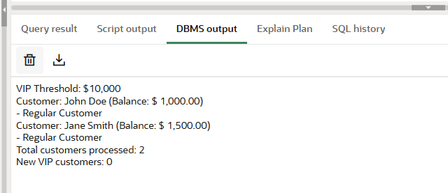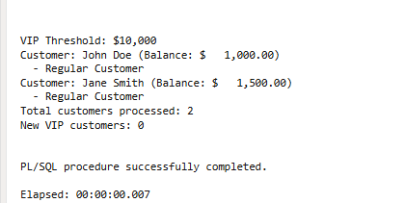

**Scenario 3:** The bank wants to send reminders to customers whose loans are due within the next 30 days.

**Question:** Write a PL/SQL block that fetches all loans due in the next 30 days and prints a reminder message for each customer.

SET SERVEROUTPUT ON;

DECLARE

v_loan_id NUMBER;

v_customer_id NUMBER;

v_customer_name VARCHAR2(100);

v_loan_amount NUMBER;

v_end_date DATE;

v_days_until_due NUMBER;

v_reminder_count NUMBER := 0;

v_counter NUMBER := 1;

v_max_loans NUMBER;

v_urgency VARCHAR2(10);

BEGIN

DBMS_OUTPUT.PUT_LINE('Checking loans due within 30 days...');

SELECT COUNT(*) INTO v_max_loans

FROM Loans

WHERE EndDate BETWEEN SYSDATE AND (SYSDATE + 30);

IF v_max_loans = 0 THEN

DBMS_OUTPUT.PUT_LINE('No loans are due within the next 30 days.');

ELSE

FOR loan_rec IN (SELECT l.LoanID, l.CustomerID, c.Name, l.LoanAmount, l.EndDate

FROM Loans l, Customers c

WHERE l.CustomerID = c.CustomerID

AND l.EndDate BETWEEN SYSDATE AND (SYSDATE + 30)

ORDER BY l.EndDate) LOOP

v_loan_id := loan_rec.LoanID;

v_customer_id := loan_rec.CustomerID;

v_customer_name := loan_rec.Name;

v_loan_amount := loan_rec.LoanAmount;

v_end_date := loan_rec.EndDate;

v_days_until_due := ROUND(v_end_date - SYSDATE);

v_reminder_count := v_reminder_count + 1;

IF v_days_until_due <= 7 THEN

v_urgency := 'URGENT';

ELSIF v_days_until_due <= 15 THEN

v_urgency := 'HIGH';

ELSE

v_urgency := 'MEDIUM';

END IF;

DBMS_OUTPUT.PUT_LINE('>>> REMINDER [' || v_urgency || '] <<<');

DBMS_OUTPUT.PUT_LINE('Dear ' || v_customer_name || ',');

DBMS_OUTPUT.PUT_LINE('Loan ID: ' || v_loan_id);

DBMS_OUTPUT.PUT_LINE('Amount: $' || TO_CHAR(v_loan_amount, '999,999.99'));

DBMS_OUTPUT.PUT_LINE('Due Date: ' || TO_CHAR(v_end_date, 'DD-MON-YYYY'));

DBMS_OUTPUT.PUT_LINE('Days Remaining: ' || v_days_until_due);

IF v_urgency = 'URGENT' THEN

DBMS_OUTPUT.PUT_LINE(' URGENT: Contact us immediately!');

ELSIF v_urgency = 'HIGH' THEN

DBMS_OUTPUT.PUT_LINE(' HIGH PRIORITY: Arrange payment soon.');

ELSE

DBMS_OUTPUT.PUT_LINE('REMINDER: Prepare for payment.');

END IF;

END LOOP;

DBMS_OUTPUT.PUT_LINE('Total reminders sent: ' || v_reminder_count);

END IF;

END;

/

**OUTPUT:**

